

Metz Engineering Co.Limited

Building & Civil Contractors

COMPANY PROFILE

# Engineering your dreams with us



Engineering your dreams with us

*Engineering your dreams with us*

Page 2



### GENERAL INFORMATION

Metz Engineering Co.Limited

Building & Civil Contractors

METZ ENGINEERING CO. LIMITED was established in 2017 and registered in 2019 as a limited company. This is a privately owned Tanzanian Company it was established to operate in Tanzania with various activities as registered in the memorandum and articles of associations.

METZ ENGINEERING CO. LIMITED has been registered by the Contractors Registration Board (CRB) of Tanzania as a Building Works and Civil Works Contractor Class SIX. METZ ENGINEERING CO. LIMITED operates under the laws and regulations of Tanzania and will always follow any associated territorial regulations in public activities.

The core factors of the company is to deliver quality work, recognize all the team members and induct for safer environments and combine technology with knowledge to provide and maintain highest quality workmanship.

### OUR VISION

To be a world-class infrastructure construction and Real Estate Development company committed to total customer satisfaction and enhancing shareholder's value, by building on our strengths - innovative designs, superlative quality of material, cutting-edge technology, timely completion and demonstrating the highest standards of workmanship.

### OUR MISSION

Metz Engineering Company Limited is a leader in providing value-added construction services to our customers by creating a successful partnership with them throughout the construction process. Our pledge is to establish lasting relationships with our customers by exceeding their expectations and gaining their trust through exceptional performance by every member of the construction team.



Engineering your dreams with us

*Engineering your dreams with us*

Page 3



## COMPANY PARTICULARS & LEGAL STATUS

Name of company **METZ ENGINEERING COMPANY LIMITED**

Date of company incorporation **20th June 2019**

Number of Certificate of incorporation **139-352-262**

Place of incorporation **Dar es Salaam, Tanzania**

Office Address **Gongo la Mboto - Stakishari (Near Stakishari Police Station)**

Postal Address **P.O Box 71003, Dar es Salaam**

Taxpayer Identification Number (TIN) **139-352-262**

VAT Registration Number (VRN)

### LEGAL STATUS

The following copies of legal status documents are enclosed herein:

* 1. Certificate of Incorporation
  2. Business License for Civil Works Contractor Class 6
  3. Business License for Building Contractor Class 6
  4. Taxpayer Identification Number (TIN)
  5. VAT Registration Number (VRN)
  6. Certificate of Registration as Civil Engineering Contractor Class 6
  7. Certificate of Registration as Building Contractor Class 6



Engineering your dreams with us

*Engineering your dreams with us*

Page 4



## BOARD OF DIRECTORS

Metz Engineering Co.Limited

Building & Civil Contractors

**Mtambalike Shinga Mtambalike**

#### Managing Director

Mtambalike S. Mtambalike is the Managing Director and shareholder of the Company. He has been associated with the Company since its incorporation. He has executed varied projects and has 20 years of experience of working in the construction industry. His leadership skills have enabled the company to execute complex projects successfully

**Qs. Ezekiel Wilson Peter**

#### Technical Director

Qs. Ezekiel Wilson is the Technical Director and Shareholder of the company. He has been associated with the company since its incorporation He is Young and dynamic; Drives the Construction & Real Estate Business Development. With passion for design, cost estimating, construction supervision, he is deeply involved in various construction activities. He has completed his University Degree (Bachelor of Science in Building Economics) from Ardhi University. Qs. Ezekiel Wilson has been registered by Architects and Quantity Surveyors Registration Board (AQRB) and also a member of Tanzania institute of Quantity Surveyors (TIQS).With his Experience in Construction Industry, proficiency of the industry and headship knacks the company targets to accomplish new altitudes in the construction industry.



Engineering your dreams with us

*Engineering your dreams with us*

Page 5

Metz Engineering Co.Limited

1. **EXECUTIVE MANAGEMENT TEAM & PERSONNEL**Building & Civil Contractors

|  |  |  |  |  |
| --- | --- | --- | --- | --- |
| **S/N** | **DESCRIPTION** | **NAME** | **QUALIFICATION** | **EXPERIENCE** |
| 1. | Finance Manager | Queen Moccah | Tax Administration | 9Yrs |
| 2. | Marketing Manager | Sadru Musiba | Bachelor Degree in Marketing | 12Yrs |
| 3. | Legal Advisor/Human Resource Mange | Juliana Changarawe | Bachelor of Law | 15Yrs |
| 4. | Sites/General Manager | Respicius S. Kabyemela | FTC. Civil Engineer | 20Yrs |
| 5. | Engineer | Twahil Abdallah | Civil and Water Resources Engineer | 5yrs |
| 6. | Engineer | Victor Marko Pallagyo | Civil Engineer | 3yrs |
| 7. | Engineer | Francis K. Magesa | Civil Engineer | 30yrs |
| 8. | Secretary | Mary Joseph Muronko | Records Management | 3yrs |
| 9. | Quantity surveyor | Irene Andrew Mnyeke |  | 7yrs |
| 10 | Construction Safety and Health Management  Officer | Wily B.M.Machumu | FTC. Civil Engineer | 25yrs |

**ASSOCIATE STAFF**

METZ ENGINEERING COMPANY LIMITED has a healthy working relationship with a number of highly qualified individual personnel who can be available for execution of assignments contracted to the company on a “fee-for-service” base.

### OUR ORGANIZATIONAL STRUCTURE

Metz Engineering Co.Limited

Building & Civil Contractors

**BOARD OF DIRECTORS**

**MANAGING DIRECTORS TECHNICAL DIRECTORS**

**COMPANY SECRETARY**

**ACCOUNT/FINANCE PROJECT MANAGER**

**MANAGING DIRECTORS**

**QUANTITY SURVEYORS**

**ENGINEERS**



Engineering your dreams with us

*Engineering your dreams with us*

Page 6



**SAFETY OFFICER SITE AGENTS**



METZ ENGINEERING CO. LIMITED will always regard the community as one of its key stakeholder, thus will be in hand to hand with the community through its social activities. We will make sure that our social responsibilities are rendered as required.

Engineering your dreams with us

*Engineering your dreams with us*

Page 7



##### OUR PRODUCT SERVICES

Metz Engineering Co.Limited

Building & Civil Contractors

We offer general contracting, construction management, design-build, and pre-construction planning services for projects of all sizes from a single office fit-up to real estate projects.

As a full service construction company, we essentially assist our clients from the very outset to the completion of their projects.

We become partners with our clients in understanding the five basic function of;

* 1. Defining and establishing the scope of the construction project.
  2. Pre-construction project planning including preparation and scheduling of the projects, phasing plans, budgeting/cost modeling and subcontractor qualification.
  3. On-site execution of the project includes scheduling, quality control, safety management, sub-contractor management, and project status reporting and change management.
  4. Monitoring and controlling the project Closing of the project related to the post construction activities.

##### PROJECT DELIVERY METHODS.

We build diverse range of projects for our clients under a variety of project delivery methods including;

* 1. Lump sum bid from completed drawings
  2. Construction management
  3. Design-build development
  4. Pre-construction services

##### A SNAPSHOT OF OUR SERVICES ARE;

* 1. Construction and Maintenance of Residential Houses, Commercial and Industrial
  2. Construction and Maintenance of Sewerage an d Drainage Systems,
  3. Interior design and partitions
  4. Landscaping
  5. Construction and Maintenance of Roads,
  6. Construction and Maintenance of Sewerage an d Drainage Systems**,**

1. **SOCIAL RESPONSIBILITY;**

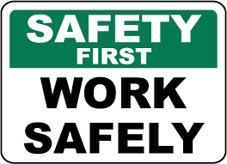

### OUR STRATEGIC OBJECTIVE

Metz Engineering Co.Limited

Building & Civil Contractors

METZ ENGINEERING CO. LIMITED has set its five (6) year corporate strategy in the following specific objectives:

* 1. To become successful construction company in the construction industry
  2. To grow its revenue by 50% and expand its business to countrywide for the coming five (5) years to 2030.
  3. To establish its long term relationship with its key stakeholders such as: clients, consultants, lenders, and financial institutions.

### KEY TO SUCCESS

The key to o ur success is our commitment to quality, our continuous investment and training in the newest technology and our focus on values and workmanship. With METZ ENGINEERING CO. LIMITED on your team you will find the experience, expertise and integrity necessary to manage and complete your next project on time and within budget.

### HEALTH AND SAFETY

For health and safety every employee working on site is insured whereas the site agents are trained to give first aid, whereas every employee or any new attendant on a new or running project are inducted for safety before working on site by the site agent who has officially been trained and inducted for site safety and can also asses risks. Employees are also trained on reducing the risks of injuries and are also trained on injury prevention methods, and are also inducted on how to use hazardous and warning signs**.**

#### Occupational Health and Safety Construction Induction

The company frequently organizes, occupational health and safety construction workshops, where all the employees are invited to attend this workshops which give a glance of safety methods and introduce new methods and train on how to asses risks, prevention of accidents and work smart ideas are introduced**.**

# Engineering your dreams with us

*Engineering your dreams with us* Page 8



*Engineering your dreams with us*

Engineering your dreams with us

Page 9



##### PLANTS AND EQUIPMENT

Metz Engineering Co.Limited

Building & Civil Contractors

The company owns the equipment listed below. Other relevant needed execute projects are normally obtained from equipment hire companies.

|  |  |  |  |
| --- | --- | --- | --- |
| **S/N** | **Equipment Description** | **Model/Type** | **Quantity** |
| **1** | Tipper-20 ton | Volvo | 1 |
| **2** | Tipper-10 ton | Nissan Diesel | 1 |
| **3** | Tipper-7 ton | Nissan Diesel | 1 |
| **4** | Tipper-7 ton | Isuzu | 1 |
| **5** | Pick up -1ton | Land Cruiser | 1 |
| **6** | Hard top | Land Cruiser | 1 |
| **7** | Asphalt concrete paver | 6-6.2,tire type VOGELE AG MANNHEM | 1 |
| **8** | Backhoe wheel loader | CGT 312 | 1 |
| **9** | Concrete Mixer | Mobile(0.35m3) | 2 |
| **10** | Vibrating Compactor | Model YZ 12 | 2 |
| **11** | Compressor | ATLAS COPCO | 1 |
| **12** | Generator | 40KVA,IVECO- ALFO | 1 |
| **13** | Water Bowser | IVECO(8,000 Lts) | 1 |
| **14** | Road Marking Machine | MD | 1 |
| **15** | Asphalt Cutter | BX 350 | 1 |
| **16** | Hand compactor |  | 1 |
| **17** | Tree cutting Machine |  | 1 |
| **18** | Water pump | SCR-80,4 inch | 2 |
| **19** | Pocker Vibrator |  | 2 |
| **20** | Plate Compactor | Petrol Engine | 2 |
| **21** | Welding Machine |  | 1 |

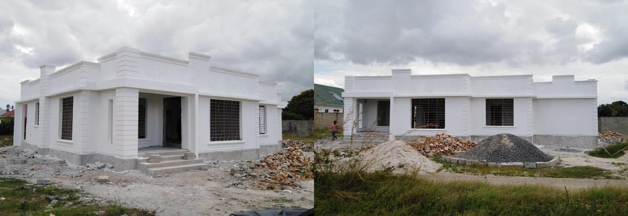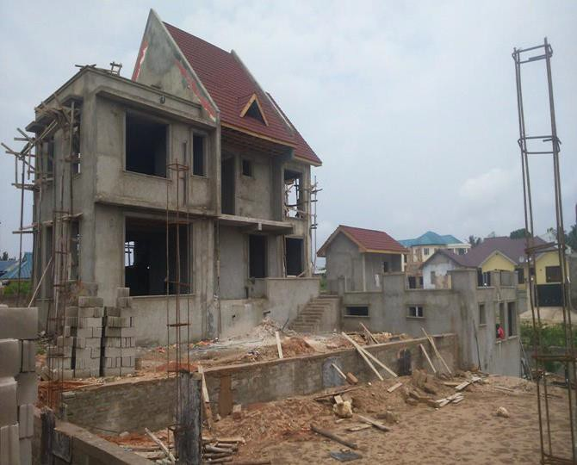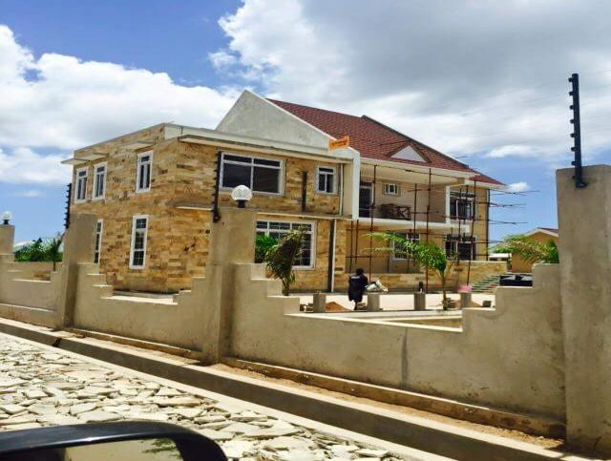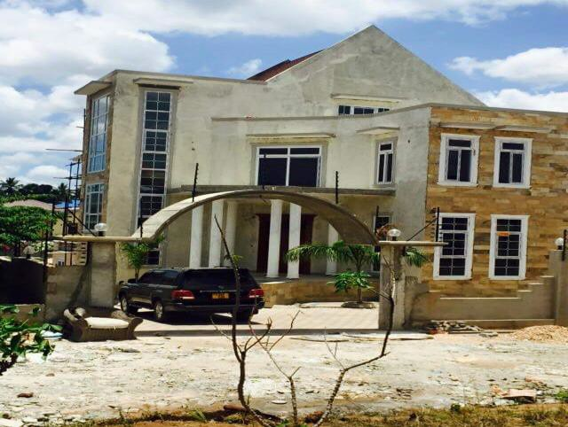

### OUR PROJECTS

Metz Engineering Co.Limited

Building & Civil Contractors

###### Construction of Residential House Built on Plot N0. 10 Block "G" at Kihonda, Morogoro

**Municipalit**E**y D**n**ar**g**es**i**S**n**ala**e**am**ering your dreams with us **Construction of Residential House Built on Plot N0. 517 Block "18" at Gezaulole, Temeke**

*Engineering your dreams with us* Page 10



Engineering your dreams with us

*Engineering your dreams with us*

Page 11

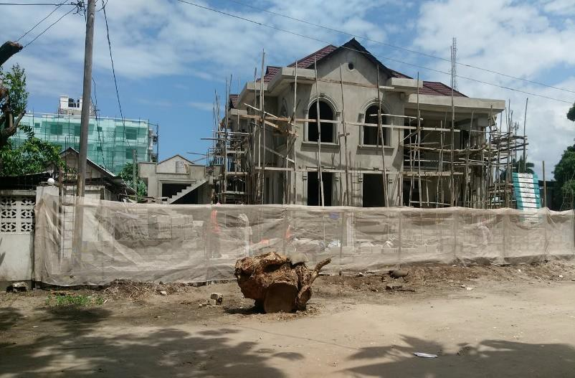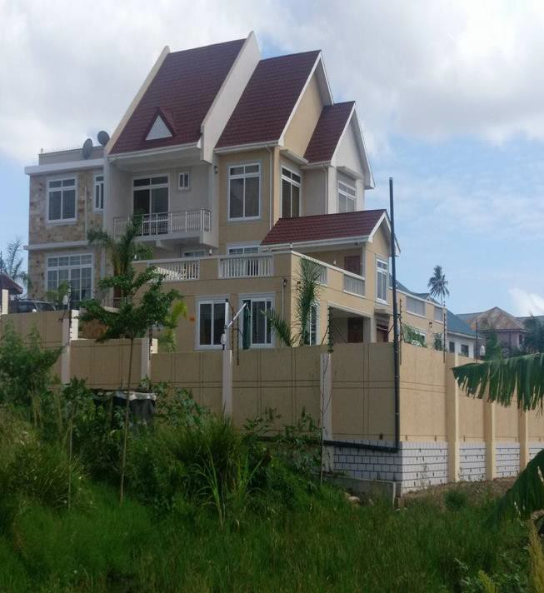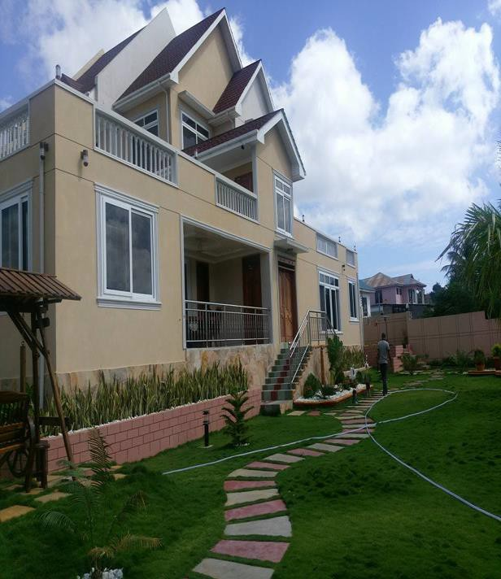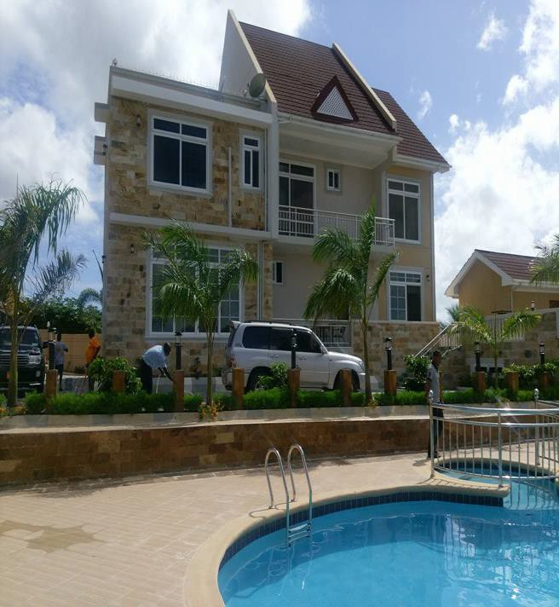

Metz Engineering Co.Limited

Building & Civil Contractors

###### Construction of Residential Apartment Built on Plot N0. 978 Block „B*‟* at Mbezi Beach Area, Kinondoni Municipality Dar es Salaam



Engineering your dreams with us

*Engineering your dreams with us*

Page 12

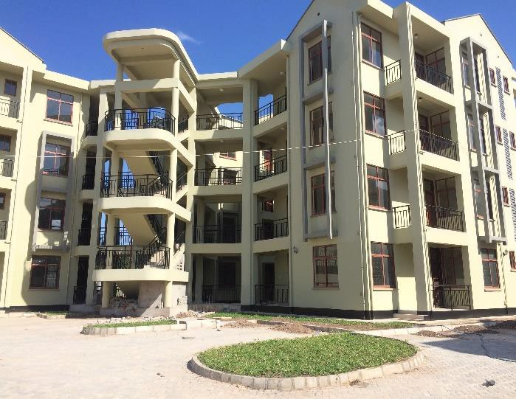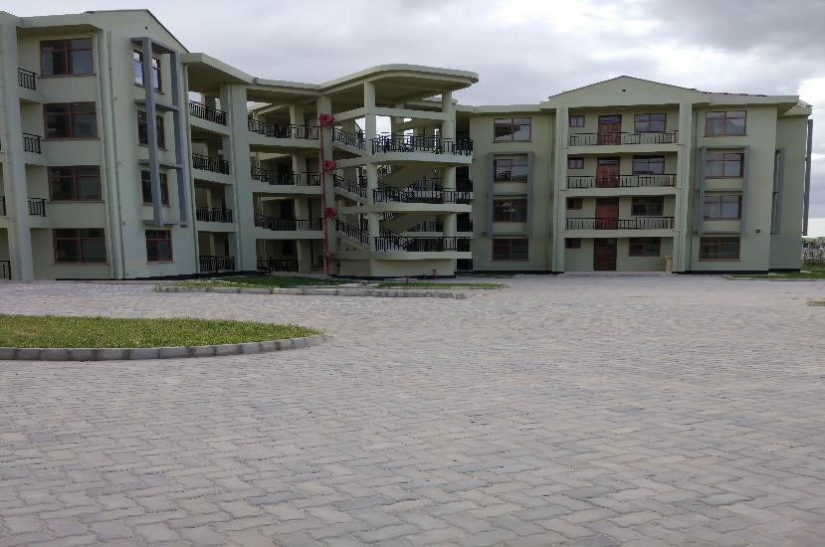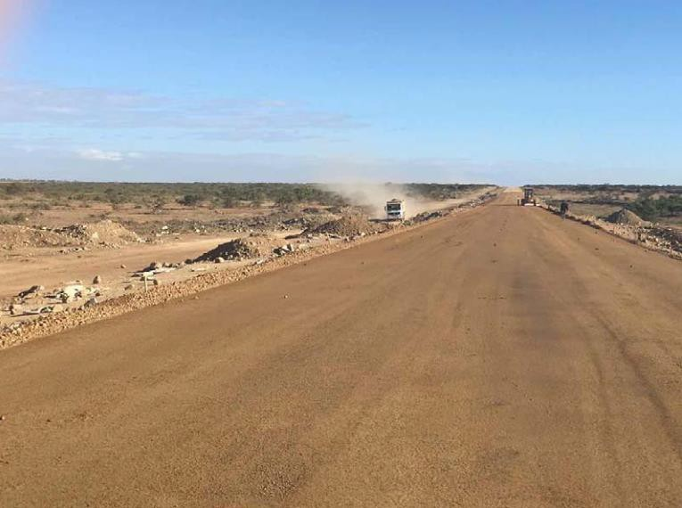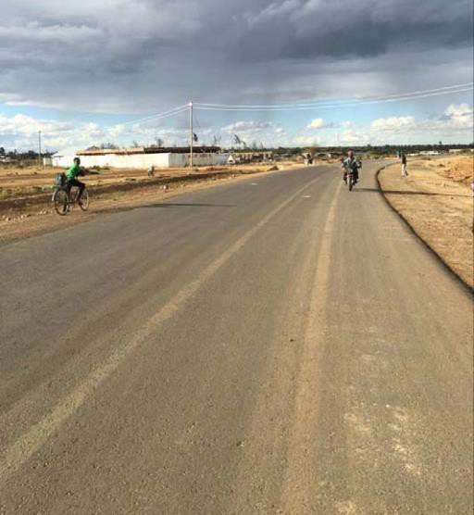

Metz Engineering Co.Limited

Building & Civil Contractors

###### Construction Of Affordable Housing Scheme Phase III At Mtoni Kijichi In Temeke Municipality-Lot11 -Dar Es Salaam Sub-contracted landscaping+ Finishing + Paint and decoration. Contract Price TZS. 218Million

**PERIODIC MAINTENANCE- WAILES ROAD, which is situated in Lindi Municipal Council. Double Surface dressing It covers 2Km as a whole. Tzs 350Million**



Engineering your dreams with us

*Engineering your dreams with us*

Page 13

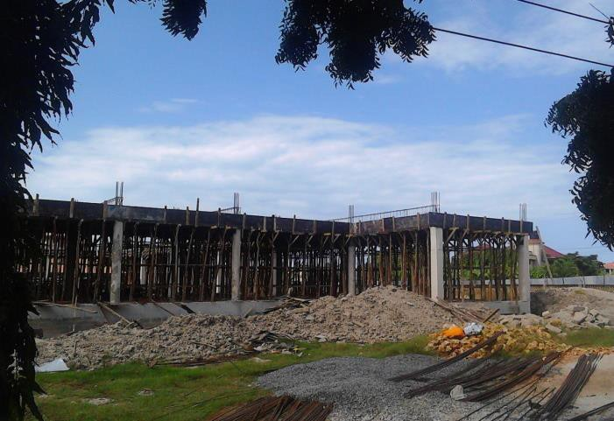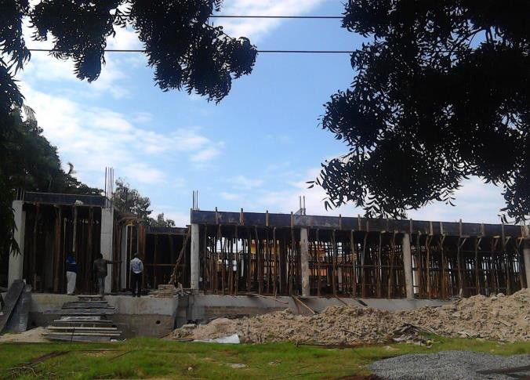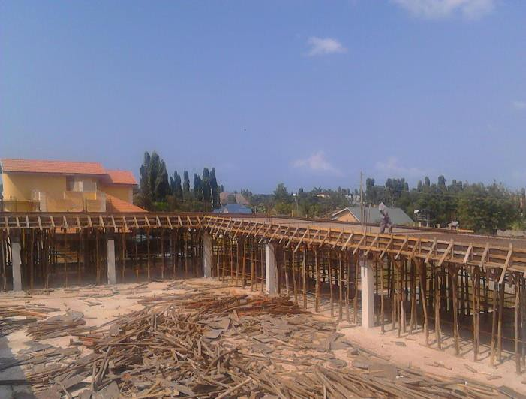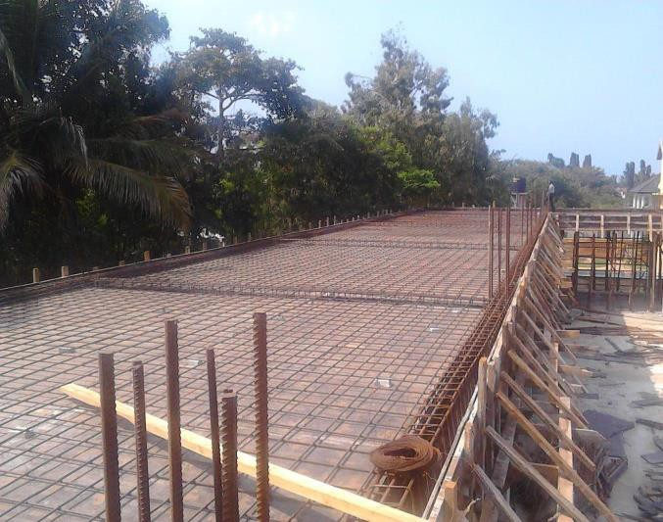

Metz Engineering Co.Limited

Building & Civil Contractors

###### Construction of Residential Apartment built on Plot N0. 45 Block „J*‟* at Mbezi Beach Area, Kinondoni Municipality Dar es Salaam

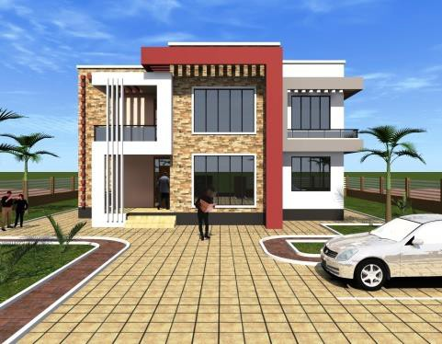 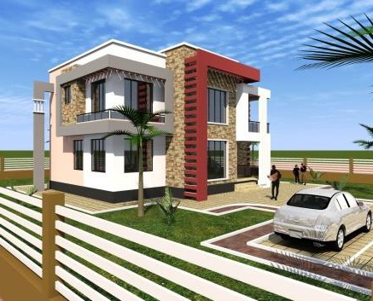 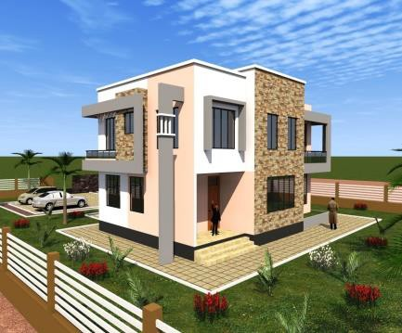

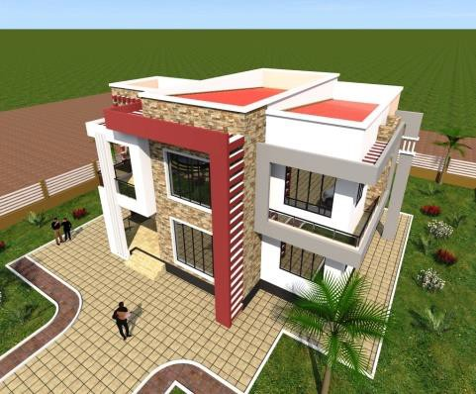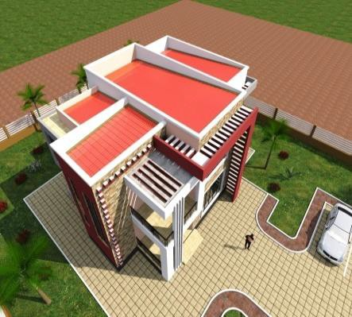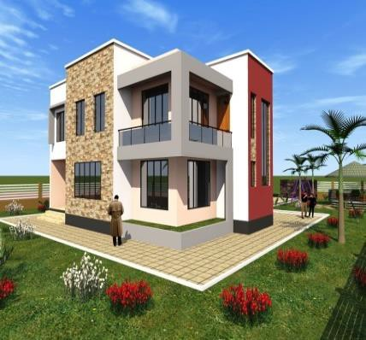

###### Construction of Residential House Built on Plot N0. 219 Block "15" at Kibada in Temeke Municipality Dar es Salaam

*Engineering your dreams with us* Page 14